PrEP and Porn: Trends in Popularity of Condom-less Pornographic Videos featuring Men having Sex with Men

Kenneth Morales

October 22, 2017

### Introduction

The film scholar Linda Williams has compared different kinds of pornography, revealing what she termed a proliferation of "diff'rent strokes for diff'rent folks." Since sexually explicit media (SEM) first came into its own in the 1970s with the beginnings of a mainstream pornographic film industry, diversification of imagery has been a central ongoing aspect of modern pornography. Since its inception, the internet has opened up niches for producers and broadcasters targeting a wide range of specific sexual desires (Williams, 1992). In Williams' early article, sadomasochistic, homosexual, and bisexual pornographies are taken to illustrate a gap between then norm and "perversity," without taking into account the new interactions between categories that stem from their co-existence. In the age of PageRank and the growing corporate dominance of pornographic production studios, however, the tyranny of the masses in SEM exemplifies a counter current: the proliferation of pornographic categories can show how hegemonic desires provide a path to other desires still, but also how other desires can be subsumed in hegemonic ones.

Barebacking, or penetrative anal sex without a condom between two men, could be a rising hegemonic desire in gay pornography. SEM has a variety of genres; some SEM portray sexual behaviors that range from ‘vanilla’ (i.e., kissing, oral sex, vaginal sex, anal sex) to ‘kink’ (i.e., extreme penetration, water sports, sadomasochism). Safer sex practices, including the portrayal of condom use, is also highly variable in SEM. Studios that primarily feature men having sex with men have generally upheld a self-imposed standard of condom use in anal sex as a response to the AIDS crisis (Grudzen 2009). Concerns for the health of performers and the effects of SEM viewership on consumer sex practices have led to policies like California’s Measure B, which mandates the use of condoms in SEM (Los Angeles Times, 2012).

While condom-less gay porn existed, it was commonly regarded as kink, and was the domain of specialized or heterodox smaller production studios. In recent years, however, porn studios have begun dropping the condom use standard, in response to competition from "tube" sites (such as PornHub), which aggregate and disseminate pornography, and burgeoning competition from amateur pornographers, many of whom provide bareback porn unrestrained by mainstream conventions. With the advent of pre-exposure prophylaxis (PrEP), however, gay porn studios had an out: they could provide bareback sex for audiences who preferred it while still bearing the mantle of "safer" sex.

PrEP is currently used almost exclusively as shorthand for the use of the antiretroviral drug Truvada, a two-drug combo manufactured by Gilead Sciences, to prevent the replication of HIV in unexposed populations. The CDC approved Truvada as PrEP in May of 2014 (CDC, 2014), and most large gay pornographic studios began producing bareback porn in the years following the CDC's endorsement.

Since 2011, five studies have examined the effects of gay SEM, all studying the relationship between bareback SEM consumption and HIV/STI risk, all of which have demonstrated varying degrees of positive association between watching unprotected anal intercourse and participating in the activity in their sex lives (Eaton et al., 2012; Nelson et al., 2014; Rosser et al., 2013; Stein et al., 2012; Traeen et al., 2014). Positive effects of SEM consumption among men who have sex with men (MSM) include sexuality education, particularly among young MSM, many of whom report learning about sexuality through this medium (Kubicek, 2010). SEM consumption has been found to positively predict higher numbers of sex partners (Braun-Courville & Rojas, 2009), though other studies did not find the same association (Rosser et al., 2013).

Given the research at present on the effects of bareback pornography on viewers, the degree of primacy of SEM depicting unprotected anal intercourse in online pornographic websites is of public health interest. The purpose of this study is to examine whether there is a correlation between the condom utilization practices employed in gay porn videos and their consumers' viewing habits on a major pornographic website in the last decade and the new guidelines recommended for Truvada to be used as pre-exposure prophylaxis (PrEP) on May 14, 2014.

### Methods

I explored the popularity of pornographic videos containing MSM by their total view count among a cross-sectional sample of SEM videos from a popular pornographic video site. [PornHub](www.pornhub.com) is the world's largest pornography website, operating now for 10 years. At the time of writing, it is the 36th most popular site on the web (Alexa, 2017). PornHub claims itself as a "platform" and a "video host:" in such a way, PornHub is capable of reaping the benefits of the massive traffic generated to its site while claiming no responsibility for the videos therein. In 2010, the start-up was bought out by a large adult entertainment conglomerate Manwin (now known as MindGeek), which owns several other similar "tube" sites as well as pornographic video production studios (Wallace, 2011).

PornHub organizes video files by "categories" to differentiate between types of content. The larger level domain (www.pornhub.com) contains content most watched by the presumed heterosexual male viewer (men and women having sex with women), while the subdomain for gay content (www.pornhub.com/gayporn) contains SEM most watched by the presumed homosexual male viewer. Videos are separated from these higher level domains by virtue of being categorized as "Gay" or not in the website's category system.

In order to be eligible for inclusion in the analysis, videos had to have been present on PornHub's servers at the time of web scraping (from September 29 - September 30, 2017), be categorized as "Gay," and be among the 500 videos listed in one of the 39 subcategory site index listings (N = 10,693, after removal of duplicates). Selection into the site index listing by category is determined by PornHub's "recently featured" tag on videos. Videos that, by virtue of categorization into the "Solo Male" category, could not have demonstrated the activity of interest were removed from the sample (1,340 videos). Only one video was scraped with an upload year prior to 2010, and was dropped from the analysis, leaving a final total of 9,353. Analyses were performed in R and videos were scraped with the R package "rvest" (R Core Team, 2017; Wickham, 2016).

Quantile regression and the quantile regression process was applied for the impact of predictor variables across quantiles. Standard errors were determined using the Hall-Sheather bandwidth rule and the Frisch-Newton algorithm was applied to the basic fitting routine due to considerations of the sample size--both are options available through the "qreg" package in R (Koenker, 2017).

The basic model for analyzing the SEM data presumes that the log-transformed penalized total view count has a linear splined conditional quantile functions of the form

$$Q_{log(y)}\left(τ|x\right)=\left\{\begin{matrix}β_{0}+β_{1}x, & x∈\left[0,4.5\right] \\ β_{0}+β_{1}x+β_{2}x, & x∈\left[4.5,7\right]\end{matrix}\right.$$

for $τ∈\left[0,1\right]$. Variables of interest were each video's view count and the year in which the video was uploaded. Separate analyses were conducted among videos identified as containing and not containing bareback sex by bareback categorization. Videos associated with one of these category labels, "bareback," were assumed to have the activity of interest: condom-less penetrative anal sex between at least two men. View count, the response variable $y$, stood in as a proxy for overall video popularity, and was measured by total video views at time of scraping. Video upload dates binned by year, $x$, were assumed to have been uploaded on Jan 1 of each year. Having no data on a time series for view count accumulation for each video, all videos were assumed to have a constant linear rate of growth from 0 views at baseline to their view count when scraped. Total view counts were then divided by the total amount of time from presumed upload dates to time of scraping, $p$, to get an accumulated views estimate one year after upload. This was done in order to control for a detection bias that could privilege older videos, which would have had a longer time to amass views. These values were then log transformed, and the resultant values were approximately normal by graphical assessment of a normal quantile-quantile plot and kernel density estimator. Sample size was too large to use the Shapiro-Wilk test for normality on view count data. Upload year was rescaled to begin at earliest upload year, 2010 to ease in interpretation. The term was splined at a presumed knot of 4.5 years after first sample upload, roughly corresponding to the CDC endorsement of Truvada as PrEP--a dummy variable indicating this assignment was utilized via interaction to determine the effect of a potential change in slope coefficient after the proposed cutoff. Data on all three variables, upload year, total view count, and bareback categorization) were available for the entire sample.

### Results

Overall counts of videos in the data, binned by upload year and bareback categorization is presented in Figure 1, along with the top five video categories by total view count across the sample.

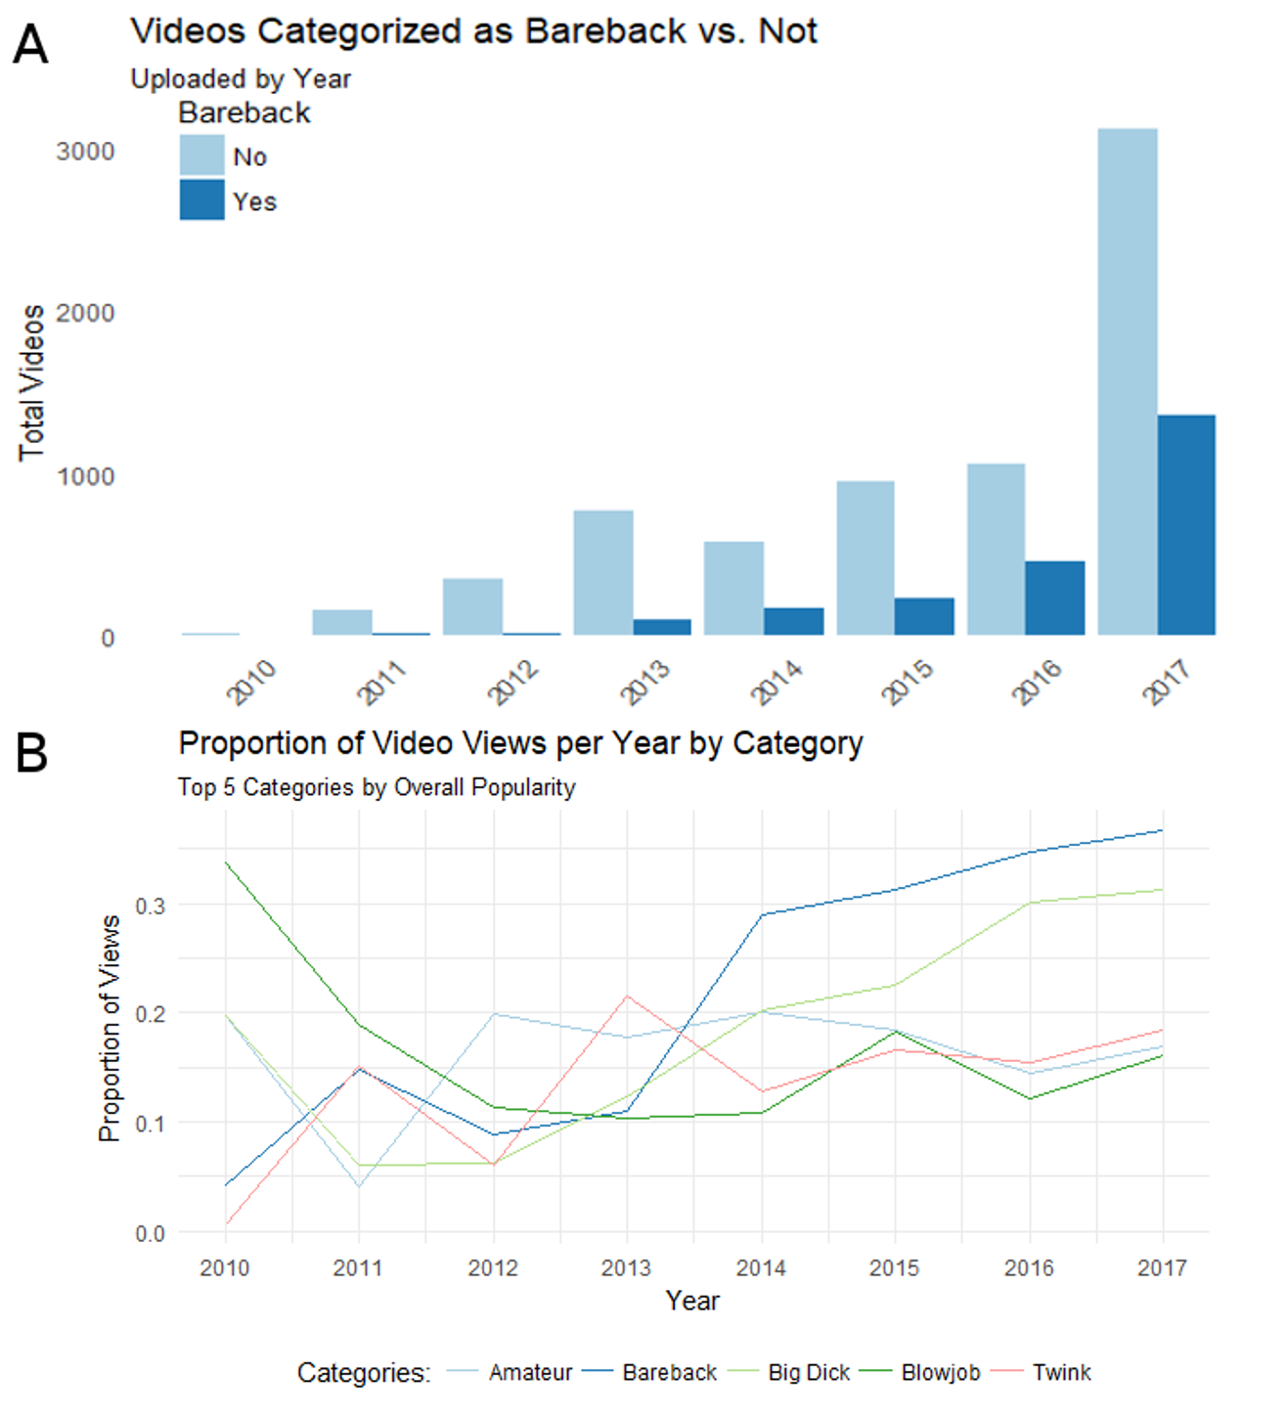

Trends in Video Upload Proportions by Bareback Categorization Across Sample. A. Upload year was strongly left-skewed. Proportionally, bareback categorized videos began seeing a marked increase in upload rates beginning in 2014. These relative subsample sizes presented graphically here should be kept in mind when discussing the insights from the quantile regression. B. Across the entire sample, the five categories with the most views were examined temporally. Bareback ends up on top at 2017, with over 37% of all views in that year attributed to this category of videos. In this sample, the relative popularity of bareback has increased over time and dominates total views.

Video upload year from the scraped data was strongly left-skewed (skewness = -1.08) and slightly leptokurtic (kertosis = 3.1). Due to this skewness and the binned nature of the upload year variable, quantile regression should serve as a robust method for identifying the effects on the quantile yearly view counts and interpretations of the quantile process should not be overly affected by bin size. A strong recency bias exists in the sample. Assuming the sample is a reasonable representation of the total upload population on PornHub by upload year, there is a general trend in a proportional increase in the number of bareback categorized videos by upload year relative to non-bareback videos: beginning in 2014, at least a quarter of all videos uploaded in a given year are bareback, and that proportion gets over 1/3 for the two most recent years 2016 and 2017. A similar trend is observed by total views accumulated across the upload years and the five most popular categories of videos. Confounding by the site index organization privileging very recent videos could explain the skewness in the sample as well. The data could also reflect a growing popularity in PornHub as a distribution platform through time.

Each of the panels of Figure 2 illustrate one coordinate of the vector-valued functions for each $\overset{^}{β}\left(τ\right)$ and their 95% confidence bands for $τ∈\left[0,1\right]$. Analysis was performed in subsamples by PornHub's bareback categorization: bareback (n = 2354) and not (n = 6998).

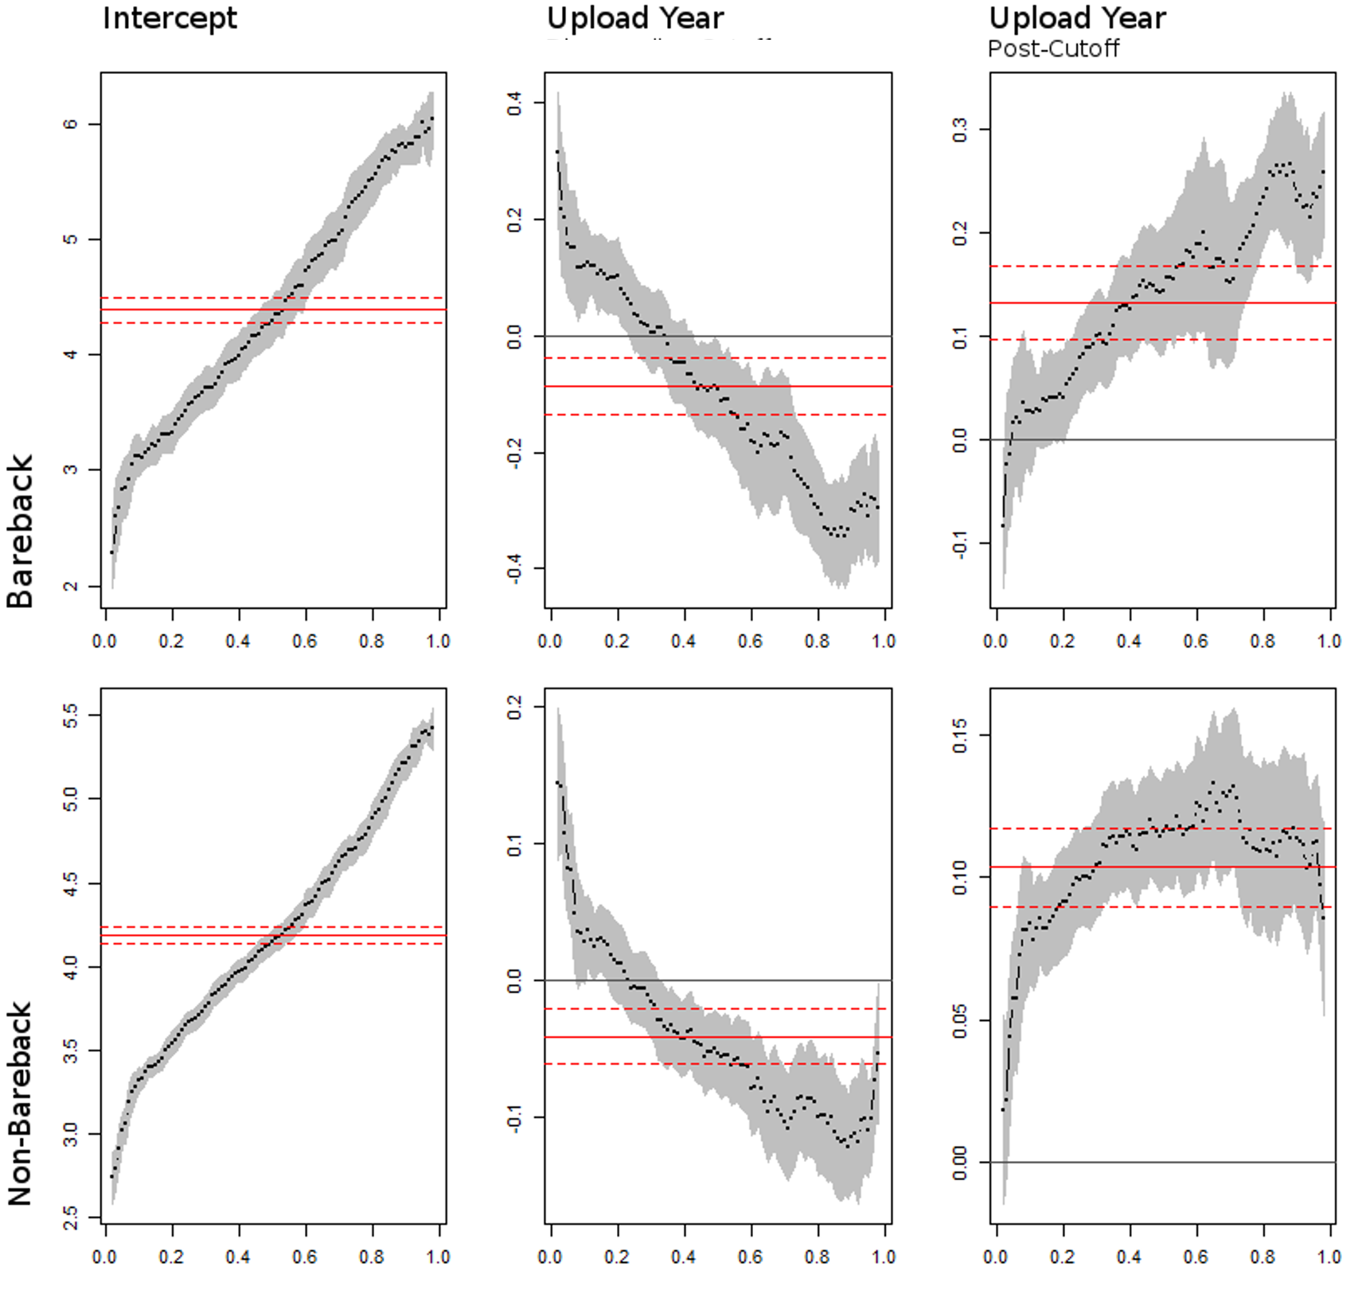

Bareback videos enjoy more popularity across quantiles. Each panel of the quantile regression process for the log viewcount model represents the vector-valued functions for each regression coefficient among the subsample of videos differentiated by bareback categorization. Y-axes are model coefficient values, X-axes are $τ$. Grey bands indicate the 95% confidence band estimates for quantile values. Solid red lines are value means, with their associated confidence interval depicted by dashed red lines. Note the differing y-axes. As a general trend, videos categorized as bareback are more popular than their non-bareback counterparts as measured by yearly log quantile viewcount. A pronouced V-shape in the total slope coefficient values is evident, indicative of both the utility of the splined upload year term and potential residual bias in the sampling methodology.

An examination of the all of the distinct quantile regression solutions for this model demonstrates a similar trend between bareback categorization and upload year and their effect on view counts, though the scale of these effects vary by categorization. Both bareback and non-bareback videos have a similar median intercept view count coefficient, though the range is larger for bareback videos (2 - 6 vs. 2.5 to 5.5). For both bareback and non-bareback videos, as $τ$ increases the coefficient effect decreases, crossing the origin at $$ 0.25 for both videos. The strength of these changes are most dramatic for bareback videos--at median view count, upload year reduces log median view count by .1 for each year after 2010, which non-bareback videos do not reach until the upper quartile, beginning at $τ$ = 0.6 and hovering around this value for the higher quantiles. The quantile process demonstrates two important temporal trends for videos uploaded from 2010 to 2014: 1) the overall trend was a gradual decline in log yearly quantile view count over time for both categorizations of videos, and 2) the more popular videos categorized as bareback ( $τ≥$ 0.5) are less likely to have been uploaded before the cutoff determined by Truvada's approval.

The interaction term, a dummy variable for videos posted after the cutoff multiplied by upload year, flips model coefficient slopes about the origin for videos uploaded within the past 3 years. For bareback categorized videos, however, the coefficient strength is as much as doubled in the upper quantiles. Non-bareback videos plateau at the 60-70th percentile of videos by popularity, while the coefficient strength continues to increase in a roughly linear fashion for bareback videos until reaching an inflection point at $τ$ = 0.7. In comparison with the magnitude of the opposing values of the uninteracted upload year variable for equal $τ$ at quantiles greater than 0.6, the net change in overall slope after the cutoff point is still in the negative direction. For the majority of the quantile distribution, however, net slope is in the positive direction, indicating a gradual increase in popularity of videos over time across all but the most popular bareback videos. A similar phenomenon is witnessed among non-bareback videos for the same $τ$ range, though the magnitude of the effect is not as great--bareback categorized videos remain more popular overall. Despite this, inference from the quantile process demonstrates an unsplined linear quantile model or linear regression on the mean would have poorly captured trends in view counts across the sample.

Table 1 lists quintile regression results with the proposed model fit. The "V"-shaped relationship between the model coefficients illustrated above is most evident in the coefficients for upload year at the $τ$ = 0.6 and 0.8 among both categorizations of videos, though the magnitude of the intercept and slope coefficients among bareback videos is greater. Significance of the upload year coefficient may be instructive in delineating temporal trends in video popularity. Among the lowest quintile, the interaction term $β_{2,BB+}$ was not significant (p = 0.13) for bareback videos, while for non-bareback videos it was the uninteracted year term $β_{1,BB-}$, evidence that relatively unpopular bareback videos are more likely to have been uploaded prior to the advent of PrEP while unpopular non-bareback videos were more likely to have been uploaded after that time. This assessment is reinforced by the relative strength of the counterpart year coefficient ( $β_{1,BB+}$ = 0.103, p < 0.001; $β_{2,BB-}$ = 0.091, p < 0.001). The model positions both types of videos roughly equivalently at $τ$ = 0.4, but from there the model diverges by bareback categorization. Among bareback videos, the upload year coefficients move from being roughly equivalent in absolute value ( $β_{1,BB+}$ = -0.182, $β_{2,BB+}$ = 0.189) at $τ$ = 0.6 to an overall reduction in popularity at the highest quintile ( $β_{1,BB+}+β_{2,BB+}$ = -0.062 net change in log-transformed yearly median view count) among videos uploaded after the cutoff. Among non-bareback videos, the trend at these quintiles is similar, though the overall change in popularity is greater for videos posted after the cutoff.

The Khmaladze test is a test of the hypothesis that the linear model specification is of the location shift or location-scale shift forms. While it is clear from the quantile regression plots that we are not dealing with a location-shift effect, as the coefficient curves would fluctuate around a constant value, it also serves as a statistical test of whether the distributions follow a location-scale shift effect. Based on this analysis, and excluding the two most extreme quantiles in (0.05, 0.95), the joint test statistic for the model testing location-scale is 3.549 and 3.549 for the bareback categorized and not so categorized videos, respectively. The asymptotic critical values at 1% is 4.119 (Koenker and Xiao, 2001). The test statistic indicating the possibility that the model specification is of the location-scale shift form is in line with the insights from the visual examination of the quantile process.

### Discussion

Data scraped from PornHub suggest an overall trend of higher view counts among videos categorized as bareback than those that are not. Quantile regression found distinctly higher quantile log view counts at all but the earliest and most unpopular of video uploads.

The data also show a distinct shift in popularity of videos around the cutoff point. Positioning the cutoff between the binned upload year values of 2014 and 2015 was dictated by the CDC's approval of Truvada having occurred in that time span; it was not driven by the data itself. It is possible that the change in slope coefficient demonstrated by the quantile regression model could be reflecting the impact of a trend shift in viewing habits at an earlier time point. For example, the CDC decision could have occurred after a growing popularity of unprotected anal intercourse in PornHub consumer's preferences. Major advertisement campaigns, a growing adoption and openness of PrEP among sexually active gay men, and the use of "hook-up apps" could all have an effect on the types of sexual content consumers may search for on pornographic websites. The change in yearly proportion of bareback videos uploaded after the cutoff, as well as their proportioon of total views, strengthens the justification for the cutoff as assigned.

The "V"-shaped pattern in the splined upload year terms with vertex at the cutoff point could be an indication of residual measuring bias, where the potential for increased views among older videos was not properly accounted for, or an indication of competition among more recently uploaded videos which may be more likely to appear together for the consumer to choose from. It is also possible that the more popular bareback videos were experiencing decline until secular trends around the cutoff point reversed that trajectory--presumably, a major announcement by the CDC, but other cultural phenomena could have taken place. The proportion of yearly uploads that are bareback, and their yearly view counts, suggest a trend change, however. The "V" pattern in model slopes could also reflect the small subsample sizes of bareback videos in the earliest upload year bins--if these happen to be quite popular videos, it would throw off the regression analysis.

While this correlation in viewer preferences does not extend directly into the actions of porn consumers, including safer sex practices and PrEP adoption, it is a notable shift that could be indicative of these and other phenomenon. Given what currently available research suggests about the impact of viewing unprotected anal intercourse, growing popularity of bareback videos has implications for public health practitioners who work with men who have sex with men or in sexually transmitted infection control. Considering also the potential instructive role porn has in demonstrating sexuality to young MSM, who also may not receive any competent or comprehensive sexuality education, the import of bareback SEM could be magnified among younger viewers.

Moves toward widespread adoption of PrEP have been divisive, politically and within gay culture. Concerns include the likelihood of PrEP being used counter to the prescription, the potential for PrEP to undermine existing safer sex policies and social mores, and the incredible cost of the drug (as high as $450 / month). Given the economic and social capital that may be required to both receive and maintain adherence to a PrEP prescription, and the relatively low bar required to have access to online pornography, there are significant health equity concerns around who may be most impacted by the viewership of unprotected anal intercourse in gay SEM. According to the CDC, men who have sex with men are at increased risk for sexually transmitted infections when compared to women and exclusively heterosexual men (CDC, 2015). Researchers and clinicians have noted an increase in sexually transmitted infections among MSM--data from San Francisco show a steep climb in incident gonorrhea and syphilis among both HIV-positive and HIV-negative gay men, even while incident HIV cases continued to decline in what one researcher termed a "pretty fascinating epidemiological divide" (Newman, 2016). While studies have demonstrated being HIV-positive and using PrEP are both independently associated with a greater likelihood of being diagnosed with an STI (Mayer et al., 2016), little research has been undertaken demonstrating potentially changing cultural mores within gay culture generally around the acceptability of unprotected anal intercourse. More research is needed to examine the ways in which non-clinical factors of gay male sociability and sexuality, including pornography use, but also use of dating apps and interpersonal communication, may also factor into the increasing trend of bacterial sexually transmitted infections among men who have sex with men.

#### Limitations

The current study operates within several limitations, imposed by the temporality of the study and the format of data storage from PornHub. Due to PornHub's robots.txt, isolating viewership by country of consumer was not possible. Their own published web traffic data by country allows for a reasonable assumption that the broader trends found without incorporating country code could reflect USA-specific viewing trends: the US generates the most traffic and has the highest per capita page views. The assumption was also made that MSM would seek out porn from this gay porn section of the website. According to PornHub's own usage statistics for 2016, ~3% of visitors from the US are "gay visitors," a statistic that is commensurate with national surveys on American's sexual orientation. This analysis was unable to control for the identity of viewers, however, and 37% of all gay male porn views on PH are from women (PornHub, 2017). I was also unable to examine videos behind PornHub's Premium service paywall. It is possible that viewing habits and the videos themselves might differ between Premium subscribers and users who only access content not behind a paywall. According to CovenantEyes, a religiously-based anti-porn advocacy organization modeled after consumer watchdogs, 9 out of 10 users access free pornography (CovenantEyes, 2017).

For this analysis, I am relying on the host-supplied bareback categorization in order to determine if a video contains sex between two or more performers without use of condoms. Additionally, for the "Solo Male" category, which is removed from the sample due to its inability to capture the activity of interest, there is an added potential for misclassification. Screening individual videos for unprotected anal intercourse was outside of the scope of this project. Upload dates were binned by year in the analysis, and only total view count amassed from the unspecified upload dates to the time of scraping were able to be examined. A finer resolution of upload date, or an ability to know the viewing trends for each video since upload, would have refined the analysis. Finally, the analysis was reliant on PornHub's organization of videos into site indexes on category, which listed the 500 most recently featured videos. There is no way to verify that the sample pooled from such a filter represent fairly the video population as a whole, or the selection criteria for videos to be recently featured.

#### Disclosure

The author participated in the gay SEM industry from 2011 - 2016 and wrote an op-ed against the Los Angeles County proposal mandating condom use in SEM in 2012 (Cooper, 2012).

### References

Alexa. The Top 500 Sites on the Web. Alexa Top 500 Global Sites, www.alexa.com/topsites. <https://www.alexa.com/topsites>

Braun-Courville, D. K., & Rojas, M. (2009). Exposure to sexually explicit web sites and adolescent sexual attitudes and behaviors. Journal of Adolescent Health, 45(2), 156–162.

Center for Disease Control (2014). HIV PrEP Guidelines: New guidelines recommend daily HIV prevention pill for those at substantial risk. May 14. Available online at <https://www.cdc.gov/nchhstp/newsroom/2014/PrEP-Guidelines-Press-Release.html>.

Center for Disease Control (2015). STDs in Men Who Have Sex with Men. 2015 Seuxally Transmitted Diseaes Surveillance, Special Focus Profiles. Available online at <https://www.cdc.gov/std/stats15/msm.htm>.

Cooper, D. Mismeasure B. The Huffington Post. Posted November 9, 2012. <https://www.huffingtonpost.com/entry/mismeasure-b_b_2094384.html>

CovenantEyes (2017). Pornography Statistics: 2015 Report. Available online at <http://www.covenanteyes.com/pornstats/>

Eaton, L. A., Cain, D. N., Pope, H., Garcia, J., & Cherry, C. (2012). The relationship between pornography use and sexual behaviors among at-risk HIV-negative men who have sex with men. Sexual Health, 9(2), 166-170.

Grudzen, C. R., Elliot, M. N., Kerndt, P. R., Shuster, M. A., Brook, R. H., & Gelberg, L. (2009). Condom use and high-risk sexual acts in adult films: A comparison of heterosexual and homosexual films. American Journal of Public Health, 99(S1), S152-S156.

Koenker, R. (2017). quantreg: Quantile Regression. R package version 5.33. <https://CRAN.R-project.org/package=quantreg>

Koenker, R. and Xiao, Z. (2002). Inference on the quantile regression process. Econometrica, 70:1583–1612.

Kubicek, K., Beyer, W. J., Weiss, G., Iverson, E., & Kipke, M. D. (2010). In the dark: Young men’s stories of sexual initiation in the absence of relevant sexual health information. Health Education & Behavior, 37(2), 243–263.

Los Angeles Times (2012). Porn industry declares war on new condom law. November 8. Los Angeles Times. Retrieved from <http://latimesblogs.latimes.com/lanow/2012/11/the-porn-industry-is-looking-for-ways-to-derail-a-voter-approved-ballot-measure-that-requires-actors-to-wear-condoms-during-f.html>

Mayer, K., Maloney, K., LEvine, K., King, D., Grasso, C., Krakower, D., and Boswell, S. HIV Infection and PrEP Use are Independently Associated with Increasing Diagnoses of Bacterial Sexually Transmitted Infections (BSTI) in Men Accessing Care at a Boston Community Health Center (CHC): 2005-2015. IDWeek 2016, Oral Abstract Session. Presented on October 29, New Orleans.

Nelson, K. M., Simoni, J. M., Morrison, D. M., George, W. H., Leickly, E., Lengua, L. L., & Hawes, S. E. (2014). Sexually explicit online media and sexual risk among men who have sex with men in the United States. Archives of Sexual Behavior, 43, 833-843.

Newman, E. (2016). STDs Among Gay Men in a New Era of PrEP. BetaBlog. June 16. Available online at <http://betablog.org/stds-among-gay-men-new-era-prep/>.

Pornhub Insights (2017). Gay Porn Pride. June 22. Available online at <https://www.pornhub.com/insights/gay-porn-pride>.

R Core Team (2017). R: A language and environment for statistical computing. R Foundation for Statistical Computing, Vienna, Austria. URL <https://www.R-project.org/>.

Rosser, B. R. S., Smolenski, D. J., Erickson, D. J., Iantaffi, A., Brady, S. S., Grey, J. A., & Wilkerson, J. M. (2013). The effects of gay sexually explicit media on the HIV risk behavior of men who have sex with men. AIDS and Behavior, 17(4), 1488–1498. <doi:10.1007/s10461-013-0454-8>

Schrimshaw EW, Antebi-Gruszka N, Downing MJ Jr. Viewing of Internet-Based Sexually Explicit Media as a Risk Factor for Condomless Anal Sex among Men Who Have Sex with Men in Four U.S. Cities. PLoS One. 2016 Apr 27;11(4):e0154439.

Stein, D., Silvera, R., Hagerty, R., & Marmor, M. (2012). Viewing pornography depicting unprotected anal intercourse: Are there implications for HIV prevention among men who have sex with men. Archives of Sexual Behavior, 41(2), 411-419.

Træen, B., Hald, G., Noor, S., Iantaffi, A., Grey, J. A., & Rosser, B. R. S. (2014). The relationship between use of sexually explicit media and sexual risk behavior in men who have sex with men: Exploring the mediating effects of sexual self-esteem and condom use self-efficacy. International Journal of Sexual Health, 26, 13–24.

Wallace, B. (2011). The Geek Kings of Smut. New York Times Magazine. Feb 7. Online at <https://web.archive.org/web/20141010205213/http://nymag.com/news/features/70985/index4.html>.

Wickham, H. (2016). rvest: Easily Harvest (Scrape) Web Pages. R package version 0.3.2. <https://CRAN.R-project.org/package=rvest>

Williams, L. (1992). ‘Pornographies On/Scene, or Diff’rent Strokes for Diff’rent Folks.’ In Sex Exposed: Sexuality and the Pornography Debate, edited by Lynne Segal and Mary McIntosh, 233-265. London: Virago.

Wilkerson, J. M., Inataffi, A., Smolenski, D. J., Brady, S. S., Horvath, K. J., Grey, J. A., & Rosser, B. R. S. (2012). The SEM risk behavior (SRB) model: A new conceptual model of how pornography influences the sexual intentions and HIV risk behavior of MSM. Sexual and Relationship Therapy, 27(3), 217-230.